PORTABLE GROUND
CONTROL STATION (PGCS)

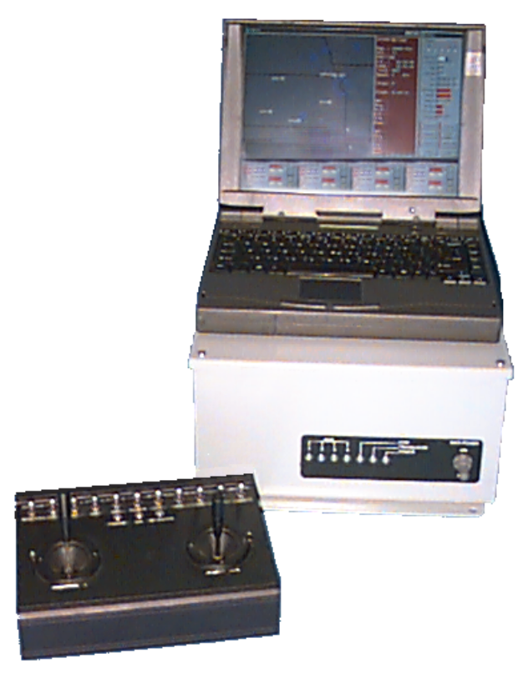

The Portable Ground Control Station (PGCS) is used by the vehicle operator to control the remote vehicle via the telemetry (TM) data stream. This includes such functions as the Smoke/Flare ignition system and power switching for payloads such as Miss Distance Indicators, radar transponders, etc.. The addition of the Autostabilizer, Altitude Hold, Global Positioning System (GPS) and TM to the remote vehicle allows for flight control beyond visual range using by using way-point navigation on a pre-determined route. The system can be operated with an independent tracking system such as a radar but with reduced capabilities which do not include way-point navigation.
The PGCS can be interfaced to numerous types of simplex, half, or full duplex Radio Frequency (RF) systems for flexible communications requirements. A simplex RF system provides increased flight and payload control capabilities over a model aircraft RC system. A half or full duplex RF system increases flexibility by providing TM down-link capabilities allowing the addition of sensors such as GPS for position information. With the bi-directional communication links and GPS, the vehicle provides it's position in a latitude, longitude format within the TM data. This allows the PGCS to track the vehicle and command it's subsequent way-point. (These way-points are determined prior to flight and stored in a way-point table for quick in-flight reference.)
The PGCS software can be easily tailored to meet increased requirements or customized to address special needs. Depending on the autopilot engine chosen, the system can range from a basic vehicle and payload control system up to a fully featured autonomous system.
The PGCS/Avionics system can be operated in either single- or multi-vehicle modes allowing the operation of one or more vehicles by a single operator. Multi-vehicle mode is typically utilized in conjunction with way-point navigation thus greatly improving presentation accuracy and minimizing operator overhead. Each vehicle can be independently designated as an autonomously or manually controlled unit. Vehicles designated as a manual unit remain under the control of the Hand Held Controller allowing it to be launched, operated locally or recovered.

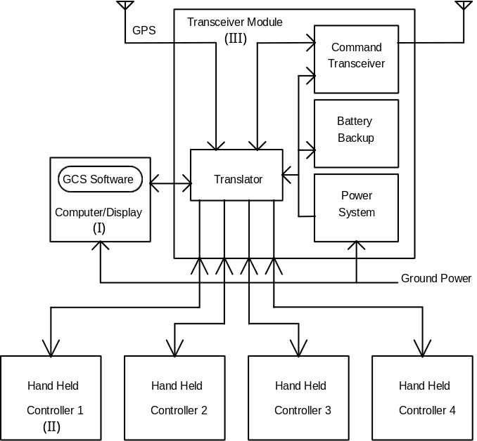
The PGCS consists of three basic modules which are outlined in the section below:

I. COMPUTER/DISPLAY MODULE
The Computer/Display Module --- which can range from a commercial PC laptop to a ruggedized, industrial unit --- provides a small, compact system for decoding and displaying the received TM data and/or GPS information. This allows a great deal of flexibility when sensors or features are added to or deleted from the system.

II. HAND HELD CONTROLLER
The Hand Held Controller allows the operator to control the aircraft manually for local or visual operation. The Hand Held Controller includes numerous on/off control switches for the remote vehicle's autopilot engine. A total of four Hand Held Controllers may be connected to the PGCS at any one time allowing for more than one operator or multiple vehicles.

III. TRANSCEIVER MODULE
The Transceiver Module incorporates the Command Transceiver, Translator and a Power System. The Translator is the heart of the Transceiver Module and provides the data exchange between each of the modules. The Translator is capable of supporting an onboard GPS unit to provide a continuously updated PGCS position for mobile (i.e. shipboard) operations.
The standard Command Transceiver combines the features of both the Command Transmitter and TM Receiver communicating with the remote vehicle in a half-duplex mode. This is a practical and cost effective solution since it is smaller and requires less power than two independent units (thus reducing battery size and weight in the remote vehicle). The combined data link allows the system to function in a multi-target scenario as well as eliminating the requirement for a separate TM antenna and frequency allocation.
The power system includes a universal input power supply and battery backup system to simplify input power requirements. This allows protection from unreliable and poorly regulated field power sources and sudden power failures. The battery backup provides the operator with ample time to rectify the problem or to return and recover the remote vehicle in such an event.
Each Transceiver Module includes a standard 5/8λ over 1/2λ omni-directional base station antenna, 30 foot (9.1m) portable mast and 50 foot (15.25m) antenna cable.
SYSTEM SPECIFICATIONS
Input Power Requirements: 100 to 240 VAC/47 to 63 Hz
Operating/Storage Temperature Ranges:
Computer/Display Module 0°C to +50°C/-55°C to +100°C
Transceiver Module 0°C to +50°C/-55°C to +100°C
Hand Held Controller -30°C to +50°C/-55°C to +100°C
Dimensions/Weight
Computer/Display Module 11.75"(29.8cm) x 9.25"(23.5cm) x 2.12" (5.4cm)/7 lbs(3.2 Kg.)
Transceiver Module 12"(30.5cm) x 13.5"(34.3cm) x 6.25"(15.9cm)/23 lbs(10.4 Kg.)
Hand Held Controller 8.5"(cm) x 6" (cm) x 4.625"(cm)/? lbs. ( Kg.)
Radio Frequency Outputs:
Command Transceiver* Standard unit operates within the following parameters:
- Narrow band FM (430 - 450 MHz. Typical)
- 9600 Baud Serial Data with 25.0 KHz. Bandwidth
- 2 Watts Output Power (5 Watts optional)
- 10 to 15 Volts DC/1.0 Amps (transmit mode)

- CJV invites requests for requirements other than those stated above.
* Specifications may vary according to particular customer requirements.
**This system will meet or exceed these specifications however operation is not guaranteed outside of these parameters.

